Exercise 1:
Step 1: Setup Git Configuration
Description:
Installed Git Bash and configured username and email.
Commands Used:
git --version
git config --global user.name "abishekkhanna"
git config --global user.email "abishekkhanna1203@gmail.com"
git config --global --list
Screenshot 1:
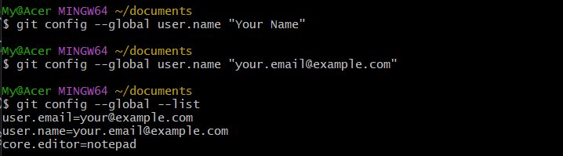

Step 2: Integrate Notepad with Git
Description:
Configured Windows Notepad as the default Git editor.
Commands Used:
Notepad
git config --global core.editor "notepad"
git config --global -e

Step 3: Create Local Repository
Description:
Created a folder GitDemo and initialized it as a Git repository.
Commands Used:
mkdir GitDemo
cd GitDemo
git init
Step 4: Add File to Repository
Description:
Created welcome.txt file and committed it.
Commands Used:
echo "Welcome to Git" > welcome.txt
git add welcome.txt
git commit
Screenshot 2:
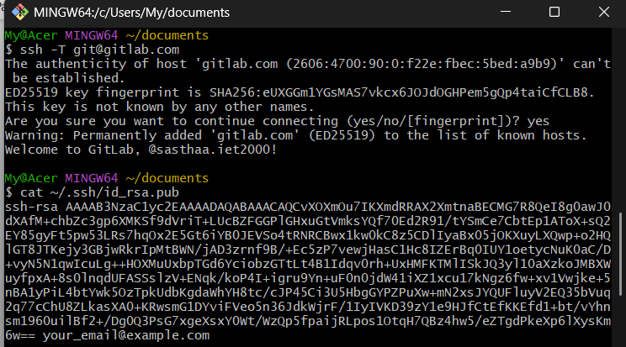

Step 5: Push to Remote Repository
Description:
Created a remote repository named GitDemo on GitLab and pushed local commits to it.
Commands Used:
git remote add origin git@gitlab.com:username/GitDemo.git
git branch -M main
git pull origin main --allow-unrelated-histories
git push origin main

Screenshot:
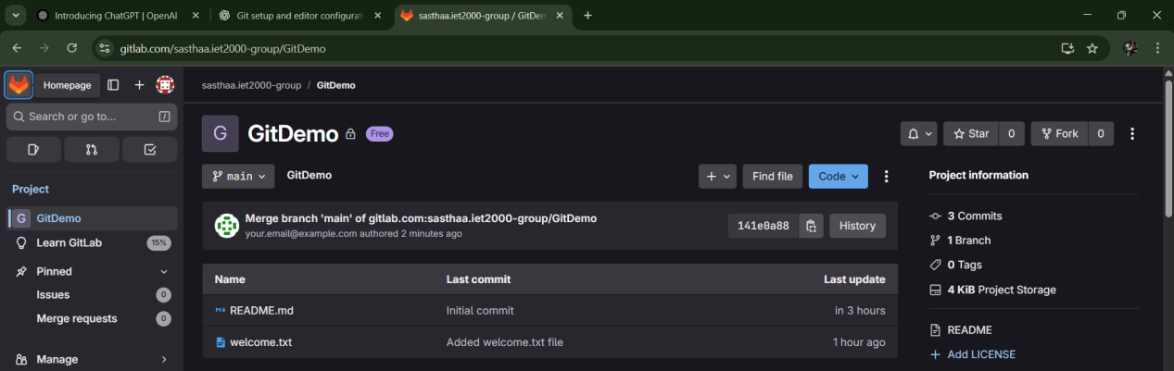

Exercise 2:

Git Hands-On: Using .gitignore

Step 1: Setup Git Repository
Description:
Opened existing `GitDemo` repository in Git Bash.
Commands Used:
cd ~/GitDemo
git status
Screenshot(1):
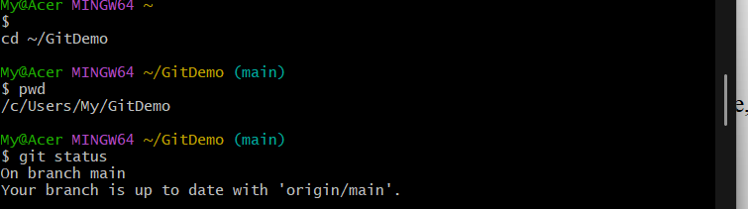

Step 2: Create Sample Files
Description:
Created a `.log` file and a `log` folder with a file inside it.
Commands Used:
echo "This is a log file" > error.log
mkdir log
echo "This is inside log folder" > log/debug.txt
Screenshot(2):
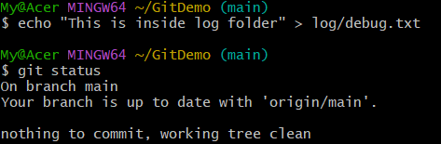

Step 3: Create and Edit `.gitignore` File
Description:
Created `.gitignore` file and added rules to ignore `.log` files and `log` folder.
Commands Used:
notepad .gitignore
# inside file:
*.log
log/
cat .gitignore
Screenshot(3):
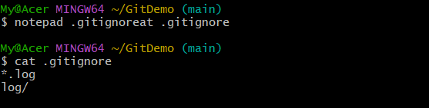

Step 4: Verify Ignored Files
Description:
Checked Git status to ensure `.log` files and `log/` folder were ignored.
Commands Used:
git status
git check-ignore -v error.log
git check-ignore -v log/debug.txt
Screenshot(4):
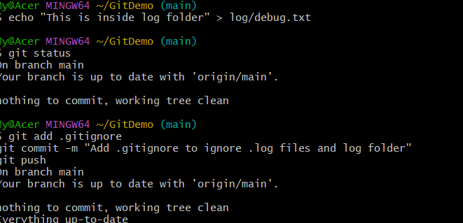

Step 5: Commit `.gitignore`
Description:
Staged and committed `.gitignore` to the repository, then pushed to GitLab.
Commands Used:
git add .gitignore
git commit -m "Add .gitignore to ignore .log files and log folder"
git push
Screenshot(5):
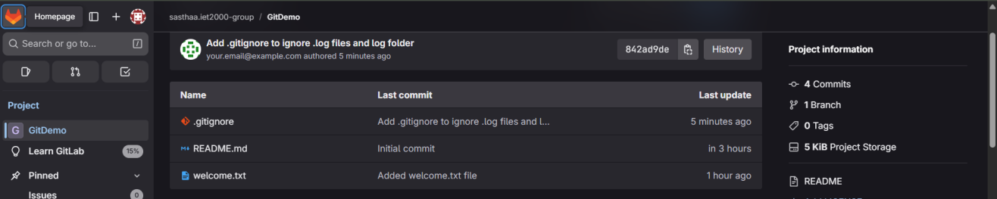

Execise 3:
Step 1: Setup Git Repository
Description:
Created a new folder myproject and initialized it as a Git repository with an initial commit.
Commands Used:
bash
CopyEdit
git --versionmkdir myprojectcd myproject
git initecho "Hello World" > file1.txt
git add file1.txt
git commit -m "Initial commit with file1.txt"

Screenshot(1):
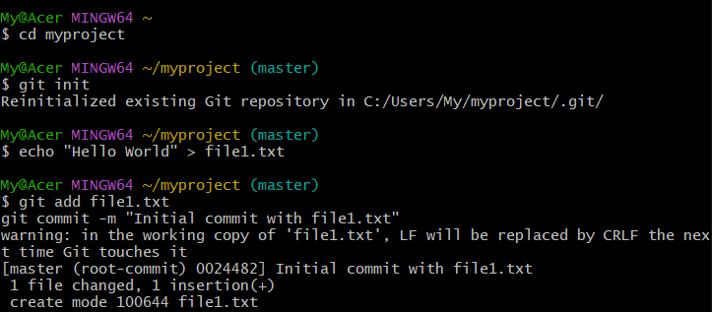
Step 2: Create a New Branch
Description:
Created a new branch named GitNewBranch and switched to it.
Commands Used:
bash
CopyEdit
git switch -c GitNewBranch

Scrrenshot(2):
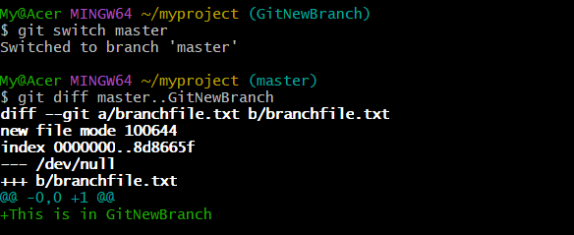
Step 3: Add Files in the Branch
Description:
Created a file named branchfile.txt in GitNewBranch, staged it, and committed it.
Commands Used:
bash
CopyEdit
echo "This is in GitNewBranch" > branchfile.txt
git add branchfile.txt
git commit -m "Add branchfile.txt on GitNewBranch"
git status

Step 4: Merge Branch into Master
Description:
Switched to master branch, viewed the differences between master and GitNewBranch, merged the branch, and viewed the commit history in a graph format.
Commands Used:
bash
CopyEdit
git switch master
git diff master..GitNewBranch
git merge --no-ff GitNewBranch -m "Merge GitNewBranch into master"
git log --oneline --graph --decorate

Screenshot(3):
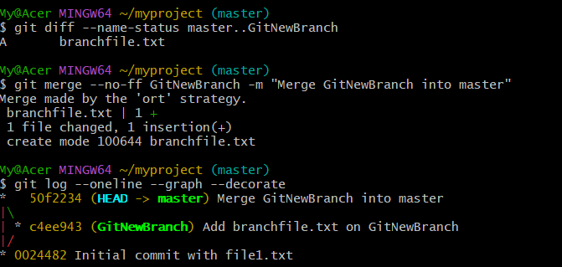
Step 5: Delete the Branch
Description:
Deleted GitNewBranch after merging and checked repository status.
Commands Used:
bash
CopyEdit
git branch -d GitNewBranch
git status

Screenshot(4):
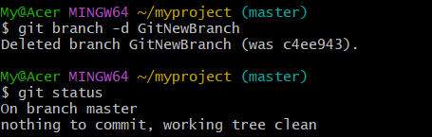
Exercise 4:
Step 1: Verify Master Branch is Clean
Description:
Checked that the master branch had no uncommitted changes before starting.
Commands Used:
bash
CopyEdit
git switch master
git status
Step 2: Create and Switch to GitWork Branch
Description:
Created a new branch GitWork from master and switched to it.
Commands Used:
bash
CopyEdit
git switch -c GitWork
Step 3: Add hello.xml in GitWork
Description:
Created hello.xml with unique content for the GitWork branch, updated it, and committed the change.
Commands Used:
bash
CopyEdit
echo "<hello>Branch initial content</hello>" > hello.xmlecho "<hello>Updated content on GitWork</hello>" > hello.xml
git add hello.xml
git commit -m "Add/update hello.xml on GitWork"
Step 4: Switch to Master and Add hello.xml
Description:
Switched back to master and created a different version of hello.xml, committing the change.
Commands Used:
bash
CopyEdit
git switch masterecho "<hello>Different content on master</hello>" > hello.xml
git add hello.xml
git commit -m "Add hello.xml on master with different content"
Step 5: View Log
Description:
Viewed all commits from both branches to prepare for merging.
Commands Used:
bash
CopyEdit
git log --oneline --graph --decorate --all
Step 6: Compare Differences
Description:
Compared file differences between master and GitWork.
Commands Used:
bash
CopyEdit
git diff master..GitWork

Step 7: Merge and Trigger Conflict
Description:
Merged GitWork into master, causing a merge conflict in hello.xml.
Commands Used:
bash
CopyEdit
git merge GitWork

Step 8: Resolve Merge Conflict
Description:
Resolved the conflict in hello.xml by combining changes, removing conflict markers, and committing the resolution.
Commands Used:
bash
CopyEdit
git add hello.xml
git commit -m "Resolve conflict in hello.xml and merge GitWork into master"
Step 9: Update .gitignore
Description:
Added rule to ignore merge backup files and committed the change.
Commands Used:
bash
CopyEdit
echo "*.orig" >> .gitignore
git add .gitignore
git commit -m "Add .gitignore to ignore merge backup files"
Step 10: Delete GitWork Branch
Description:
Deleted the merged GitWork branch.
Commands Used:
bash
CopyEdit
git branch -d GitWork
Step 11: View Final Commit History
Description:
Viewed commit history in a graphical format to confirm merge and branch deletion.
Commands Used:
bash
CopyEdit
git log --oneline --graph --decorate

Screenshot:
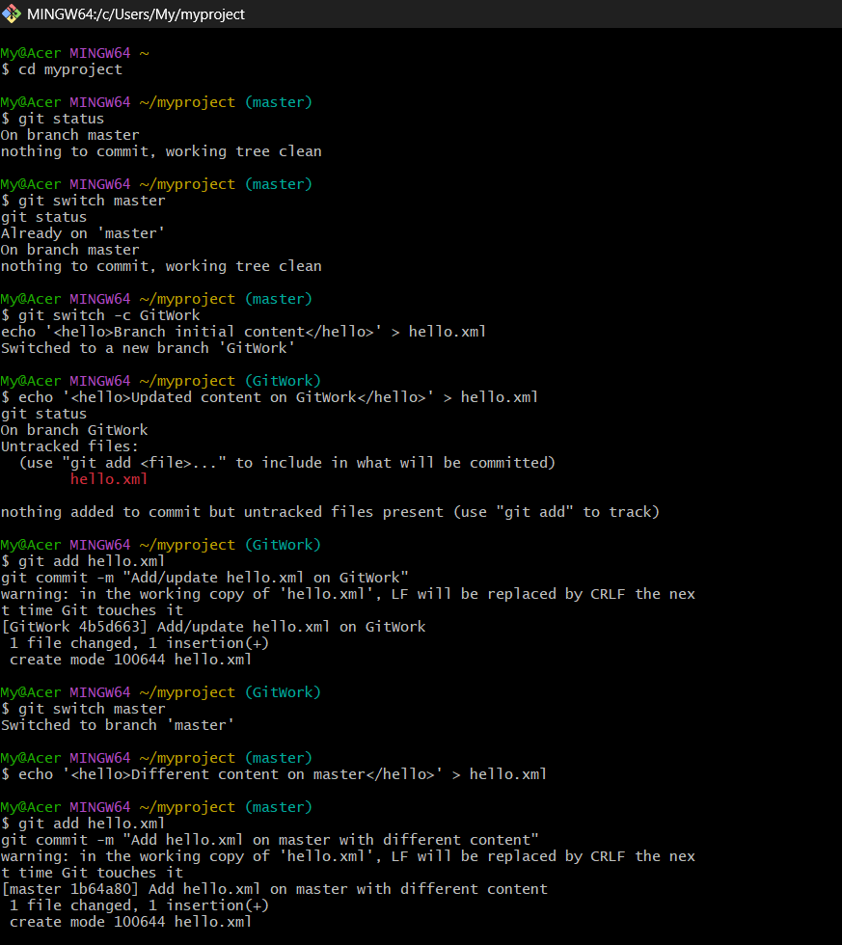
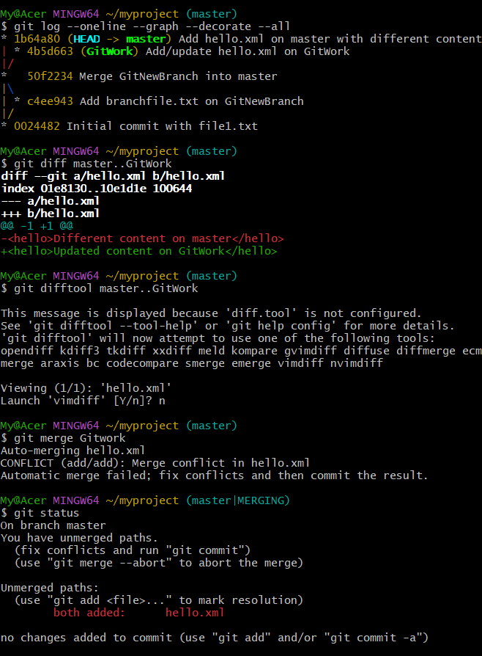
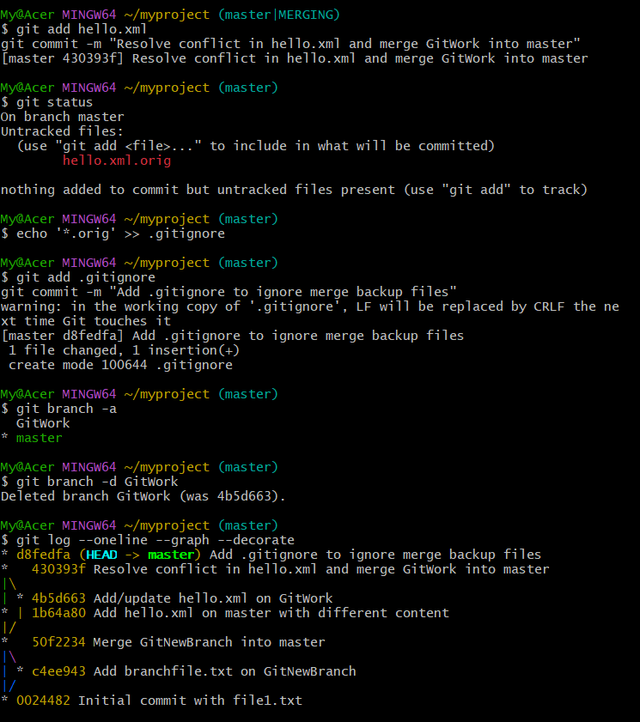

Exercise 5:
Step 1: Verify Master Branch is Clean
Description:
Navigated to the existing myproject repository and confirmed that the master branch has no uncommitted changes.
Commands Used:
bash
CopyEdit
cd ~/myproject
git switch master
git status
Screenshot(1):
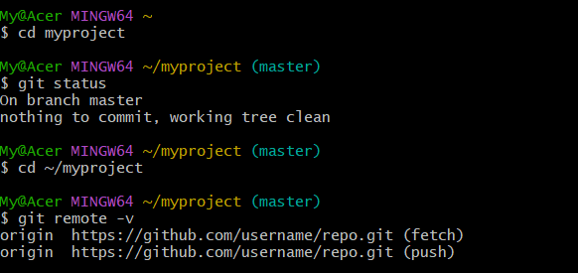Step 2: List All Branches
Description:
Listed all available local and remote branches.
Commands Used:
bash
CopyEdit
git branch -a

Screenshot(2):
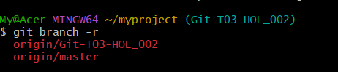

Step 3: Pull Remote Repository into Master
Description:
Pulled the latest changes from the remote master branch into the local master.
Commands Used:
bash
CopyEdit
git pull origin master

Scrennshot(3):
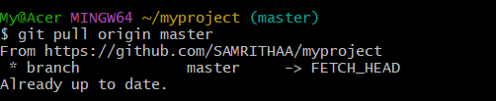
Step 4: Push Git-T03-HOL_002 to Remote
Description:
Created the branch Git-T03-HOL_002, switched to it, and pushed it to the remote repository, setting it to track origin/Git-T03-HOL_002.
Commands Used:
bash
CopyEdit
git switch -c Git-T03-HOL_002
git push -u origin Git-T03-HOL_002

Screenshot(4):
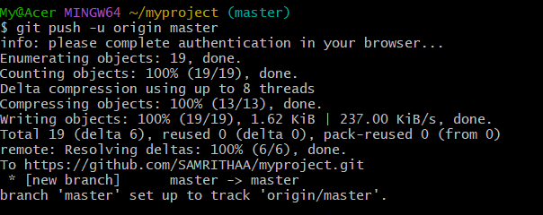
Step 5: Verify Changes on Remote
Description:
Viewed the GitHub repository to confirm the presence of both master and Git-T03-HOL_002 branches.
Commands Used:
bash
CopyEdit
git branch -a

Screenshot(5):
